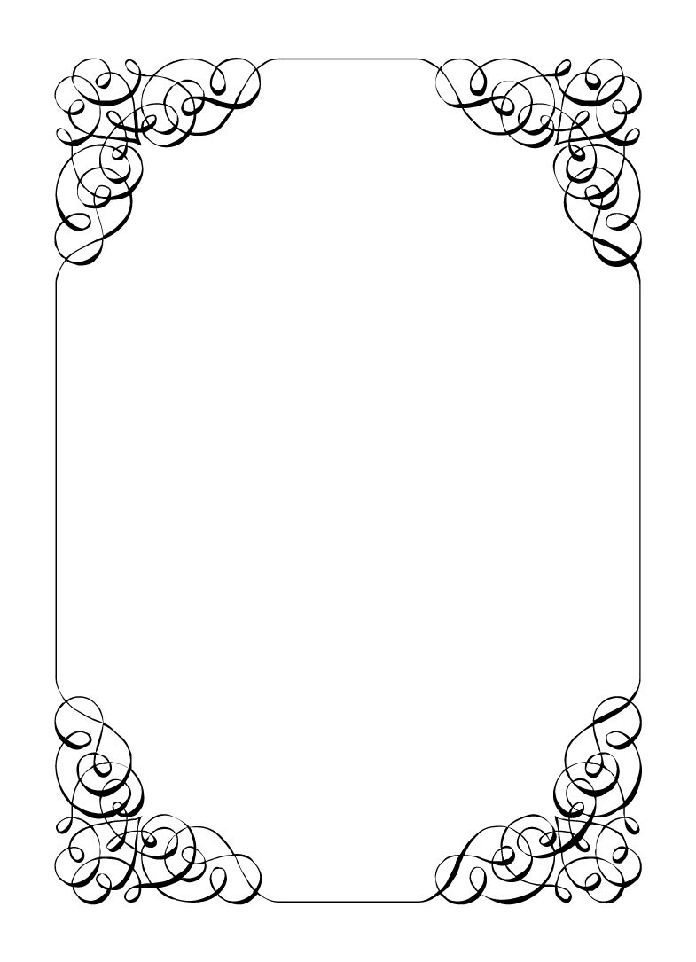

Not here to wed spiders

Vectra Marolla

*In the small town of Duck Rise, Victoria, Stralya live: BOGANS. Bogans are much like the regular folk, but drunker and louder. Some of them even fall in love. But before they settle down and poop out a mess of kids, they gotta have a wedding! Weddings are the best. Everyone gets proper plastered. Lots of kissing. Lots of drama. Fun times for all. Nothing ever goes wrong at a wedding...*  
*\*\*ominous thunder clack\*\**

Vectra Marolla

Groom's Mother *Protective, Classy, Liar*

You are the unofficial Queen of this town. Nothing happens without your say so and everyone respects that. And it is good to be the Queen. If only you could find your King...  
When you found out that Chad was marrying his secret half-sister, you knew you had to stop it. Even if you couldn't say the reason why. Everything you do today, you do for the good of your son! He just doesn't know what is best right now, but you are confident he will come around.   
  
Last Night: You were are the bachelorette party. It was you, Gemini, Mercedes, Corolla, and Mungo. You brought the drinks, and deliberatly got Gemini drunk. You lead everyone on a wild night of the Casino, Pole Dancing and car hooning. Mercedes left when y'all got to the casino.  
When Gemini brought out the wedding ring at the casino, you realised it was your chance to sabotage the wedding. You stole the ring and threw it in the trash just before getting to the wedding today.  
You didn't drink a drop last night.

**Goals**

* **Make sure Chad and Corolla do NOT get married:** While it will be too shameful to say the real reason (they are half siblings), sabotage the wedding at every chance you get. Object during the ceremony!
* **Don't let anyone know you stole the BIG rings at the Bachelorette party:** You threw them in the trash at the casino, but somehow people are putting together the dots from last night.
* **Find a way to pay for this wedding:** Sparkie didn't pay a dime, so now you need to come up with $10k before 'they' break your pretty knees.
* **Find the love of your life:** Weddings (even ones that need stopping) are so romantic. Maybe the love of your life is in the crowd. Find them and lock that shit down, you are too old to play games.
* **Mercedes is in need of a mother figure:** Her mother is no longer in the picture, it's the right thing to do.
* **Catch the bouquet while still looking classy:** You would rather a respectable woman gets the bouquet than these little shits.

**Other People**

**Chad Marolla**

He's ya son. Ya love ya son, don't ya? Of course. He is the most special, most handsome, most interesting person ever. Even if others say he's a bit boring. You would do anything for him.

**Gemini Belmont**

Just because she left town for school doesn't make her smart enough to not be over fed drinks. You have that drunky wrapped around your finger.

**Mercedes Bennie**

You love this little tyrant. She knows what she wants, and knows just who and what to stomp on to get it. She reminds you of you when you were young.

**Robin Smith**

They think they are in charge. You are in charge. They are standing in the way of you stopping this wedding. Boozed up weirdo needs to go.

**Malibu Singer**

They are a good enough person, but they are just incompetent enough to crash and burn this whole ship. That good for you, so best to just leave them be.

**Sparkie Castro**

A long time ago, you had a fling. Sparkie couldn't get his shit together though, and you cut him loose. What a dead beat. Luckily he never noticed that 9 months later you had Chad. Unluckily, that means they are half-siblings...

**Mungo Joint**

You get what you pay for. They are meant to be chronicling this special day, but you have caught them just vacantly staring into space a little too often.

**Abilities**

Use these to do things. They have a limited use, so check them off when you use them.

|  |  |
| --- | --- |
| Ability | We haven't caught up in ages |
| If you sustain a conversation for a minute with at least two other players simultaneously, each player in the conversation needs to reveal their information to everyone else in conversation (you included.) |
| Usages: O O O |

|  |  |
| --- | --- |
| Ability | Conversationalist |
| Chat with a sober (non-intoxicated) player, then show them this ability. They must reveal their secret to you. |
| Usages: O O O |

|  |  |
| --- | --- |
| Ability | Never ask a lady her age |
| If someone uses an ability on you that forces you to reveal your information or secret, show this ability to them and keep your information or secret hidden instead. |
| Usages: O O O |

**Secret and Information**

Your Secret contains your guilty secret, while your Information contains one or more items of information you know. Both may be affected by abilities. Your lie may need to be filled out later.

While you can show your Secret and Information to whomever you like, you will probably not want to reveal your Secret too often. (Please note that you can’t solve the crime by looking at everyone’s Secret and Information – it’s not that easy!)

|  |  |
| --- | --- |
| Secret | 20 years ago you had an affair with Sparkie. |

|  |  |
| --- | --- |
| Information | You brought the nicer boxed wine to the Bachelorette party and made it a real party. |

**The Organiser’s Word is Law:** The organisers are impartial. If you have a problem or want to do something unusual, see an organiser. The organiser’s power is absolute – and cannot be affected by ability cards!

**Winning and Losing:** You can achieve most of your goals simply by talking to people. The organisers will announce when the game is over. If you haven’t succeeded by that point – you’re too late! Be warned – not everyone here will want you to succeed!

**Doing Stuff:** Ordinary actions are resolved by simply carrying them out. If you want to try something unusual (such as trying to hack the pentagon), see an organiser. The organisers knows everything – and will be able to tell you the outcome of whatever it is that you are trying to do. (For example, you are trying to hack over state lines and you are caught.) Do use your imagination, though! – this is a very flexible game, and you can do all sorts of things beyond what’s listed in these rules.

**Fighting:** If an ability or item lets you hard another player, don’t just dive in! See the organisers first and tell them what you plan to do so they can oversee and give you more detailed rules if it’s necessary.

**Leaving:** You cannot leave, it is rude to leave a wedding and you are in the middle of nowhere!

**Role Cards:** If someone asks you for your role in the wedding ceremony, and you have one, you must show them all your roles.

**Item Cards:** Any items of importance within the game are represented as Item cards – and the only items that can affect the game are those detailed on the cards. If you do not have an Item card, you do not have that item with you.

**Time:** This game is played over three (ish) hours, including time for reading your character etc. There will be breaks throughout the evening! The organisers will tell you when each period starts and finishes.

**Character List**

**Chad Marolla – *Groom***

The soon to be husband. A bit nervous about the wedding, but is letting Corolla take care of the hard stuff.

**Corolla Castro – *Bride***

She knows what kind of wedding she wants, and that's the kind of wedding we are having! NO EXCEPTIONS!

**Gemini Belmont – *Maid of Honour***

She carries herself like she just escaped a warzone. Maybe she did? She's real quiet and might throat punch you if you ask stupid questions.

**Mercedes Bennie – *Flowergirl***

She's 12 but everyone knows better than to treat her like a 12 year old. Punk AF and will burn this all down on a whim.

**Robin Smith – *Priest***

Not from here. Better than everyone else (or at least thinks so).

**Dave Torana – *Best Man***

Childhood friends with the Groom. He was the smooth talking hottie that picked up enough for both of them. But that part of his life is over now.

**Malibu Singer – *Wedding Planner***

For a professional organiser, not very organised. Has just managed to keep everything running so far.

**Sparkie Castro – *Bride's Father***

He's been waiting his whole life for this moment. His baby girl is finally gonna get married and he knows just how to get through the day without crying...

**Vectra Marolla – *Groom's Mother***

The Queen that runs this town. Knows where the bodies are buried, but will never tell. Everyone respects her.

**Wayne Marolla – *Drunk Uncle***

He's maybe had a few too many. Started stumbling around and saying weird things. Every wedding has one.

**Lucky the Wonder Dog – *Dog***

A good dog. *bark* *bark* "What's that Lucky? You want pats?"

**Mungo Joint – *Photographer***

Seems like they are creeping on everyone, but they were hired to take wedding photos so it's probably fine.